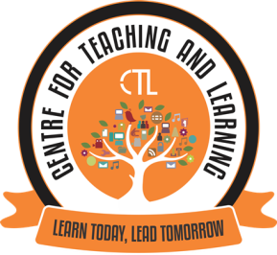
The Centre for Teaching Learning (CTL) in association with the IQAC of the College, organised the Expert FDP webinar series III on the topic “Preparing for Remote Teaching and Learning; Sharing Experiences” on 5th October, 2020 for the college faculty.
Dr. Aparna Katre, Associate Professor of Cultural Entrepreneurship, Department of World Languages and Cultures, College of Liberal Arts, University of Minnesota - Duluth, USA was the resource person for this FDP.
This FDP focussed on Sharing of Experiences with respect to Remote Teaching Learning Evaluation(TLE) from Foreign Universities; Exposure to the Faculty to various online TLE Trends. The Resource person focussed on the three main topics i.e Thinking about Curriculum, Student Engagement, Student Feedback-Formative and Summative.
The FDP webinar Series III was attended by around 23 college faculty.

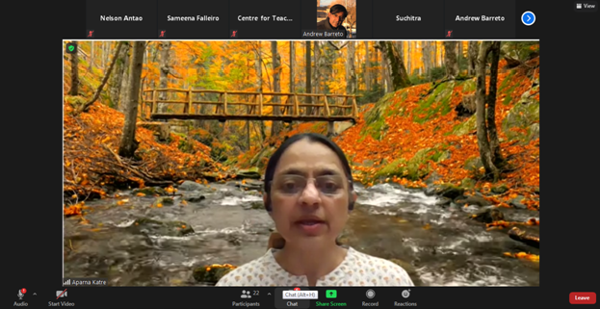
Dr. Aparna Katre, Resource person delivering the session on Preparing for Remote Teaching Learning

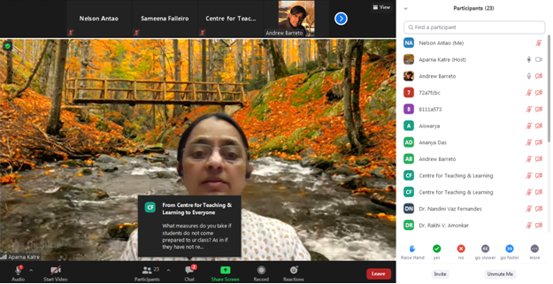
Dr. Aparna Katre, while delivering the session also addressed to all the questions raised by the faculty’s

